Steps for Installation of OpenMP
- STEP 1: Check the GCC version of the compiler
gcc --version
GCC provides support for OpenMP starting from its version 4.2.0. So if the system has GCC compiler with the version higher than 4.2.0, then it must have OpenMP features configured with it.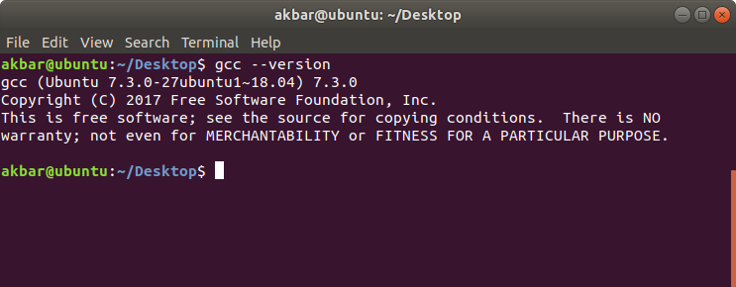If the system doesn’t have the GCC compiler, we can use the following command
sudo apt install gcc
For more detailed support for installation, we can refer here
- STEP 2: Configuring OpenMP We can check whether the OpenMP features are configured into our compiler or not, using the command
echo |cpp -fopenmp -dM |grep -i open
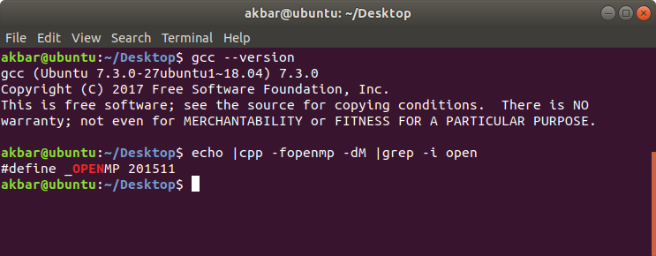If OpenMP is not featured in the compiler, we can configure it use using the command
sudo apt install libomp-dev
- STEP 3: Setting the number of threads In OpenMP, Before running the code, we can initialise the number of threads to be executed using the following command. Here, we set the number of threads to be getting executed to be 8 threads.
export OMP_NUM_THREADS=8
Running First Code in OpenMP
- C
// OpenMP header
#include <omp.h>
#include <stdio.h>
#include <stdlib.h>

int main(int argc, char* argv[])
{
int nthreads, tid;

// Begin of parallel region
#pragma omp parallel private(nthreads, tid)
{
// Getting thread number
tid = omp_get_thread_num();
printf("Welcome to GFG from thread = %d\n",
tid);

if (tid == 0) {

// Only master thread does this
nthreads = omp_get_num_threads();
printf("Number of threads = %d\n",
nthreads);
}
}
}
Output:
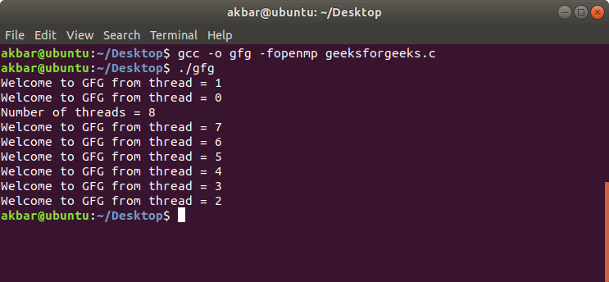
This program will print a message which will be getting executed by various threads.
Compile:
gcc -o gfg -fopenmp geeksforgeeks.c
Execute:
./gfg

For cpp :
g++ filename.cpp -o output_filename_name
./output_file_name

For cuda :
nvcc hello.cu -o hello
./hello

